Two Sandcastle projects are checked in for building the .NET Gadgeteer Core reference documentation. These are the projects used for the May 15, 2012 builds of the documentation for versions of the assemblies that support NETMF 4.1 and NETMF 4.2.

Sandcastle can be installed from the codeplex site: <http://shfb.codeplex.com/>

NOTE: The installer .zip file may be blocked by Windows. It must be unblocked before unzipping or else Sandcastle will not install properly. To do this, right-click the .zip file, choose “Properties”, and click “Unblock”.

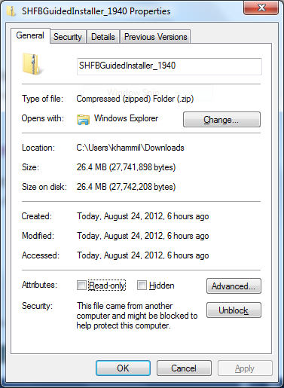

The GUI, as shown below, is easy to use. Most of default options are usable.

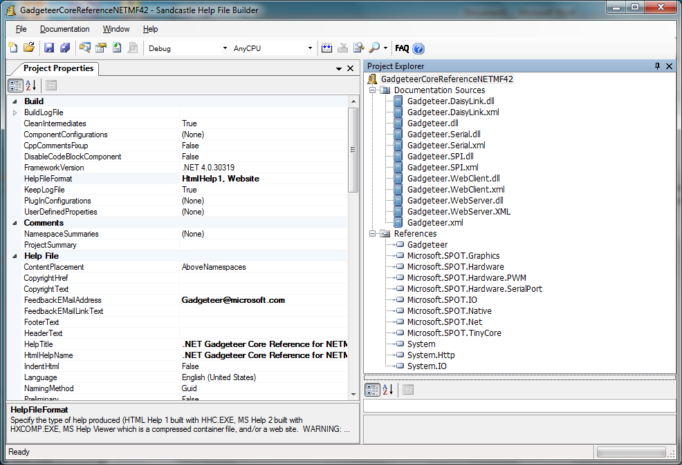

The following procedure will set up the GUI for a build:

1. Specify the HelpFileFormat. This is the output of the tool. We’re using both Website and chm (HtmlHelp1), as in the following screen shot.

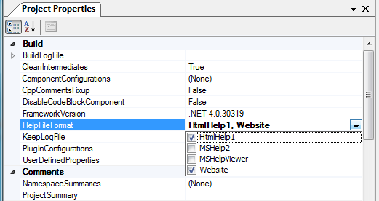

1. Set the Feedback EMailAddress and names the output files.

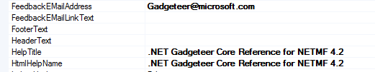

1. Select the code language syntax: C# for NETMF 4.1 and both C# and Visual Basic for NETMF 4.2.

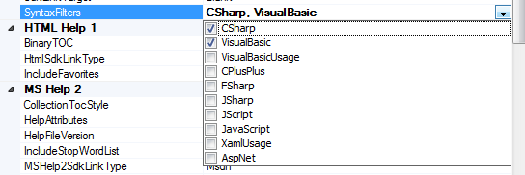

1. Specify the OutputPath.

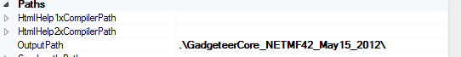

1. The Show Missing Tags options we’ve been using are as follows.

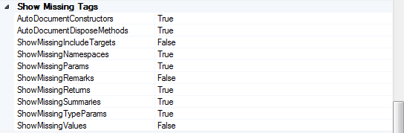

1. Build the version of the assemblies that will be documented using Visual Studio TFS and add the DLL files to the list as shown in the following screen shot. You’ll need both the project DLLs and any other assemblies on which they depend. Right click Documentation Sources in the Project Explorer, and the DLLs. The easiest way to find the dependencies is to attempt a build. Missing assemblies will be listed, one at a time in the output, and you can add them as needed. The dependencies for the Core assemblies are found at C:\Program Files (x86)\Microsoft .NET Micro Framework.

NOTE: The Sandcastle project stores relative paths to both documentation sources and references. This makes the configuration somewhat machine-specific. You may need to fix up the paths if your directory layout differs from what the project expects.

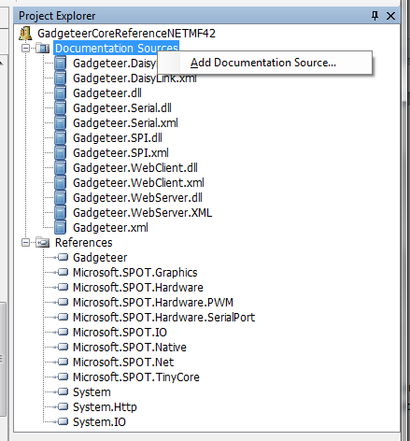

1. Build the project.